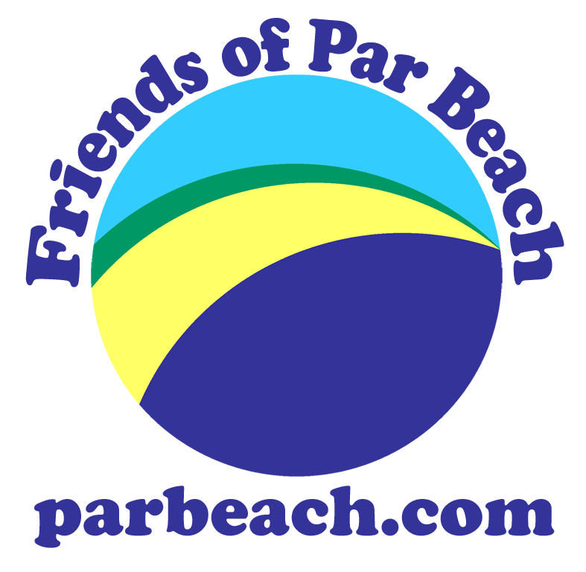
Corporate Membership Form
- promote the conservation and sensitive use of Par Beach in association with the various owners/stakeholders
- advise and assist in the management of Par Beach and the local nature reserve
- promote knowledge of all aspects of Par Beach, particularly the history, natural history and ecology
- support and encourage user groups and organisations with an interest in Par Beach
- increase and encourage the use of the beach by all
- promote and provide social, recreational, educational, cultural, sporting and conservation activities
Please tear off, complete both sides and send to the Treasurer (address overleaf).

NAME:…………………….………………………..…………………COMPANY/CLUB: ……………………………….…………………...................
Website or Contact No.: ……………………………………………………………………………………..…………………………......................…..
ADDRESS: ………………………………………………………….............…………....................................…………...........................................
…………….…………….……………………..........................................………….......................................…………...........................................
TELEPHONE: …..……………...............................................EMAIL: ………………………………………………………..........................……...

SIGNED: ………………………………………………………………………………………………DATE: ....................................................………

Minimum Annual Subscription Amount enclosed
£20 Corporate Membership £…………
£any Donation £…………
Total £…………

I enclose cash/cheque payable to Friends of Par Beach

Tick for a Standing Order form for membership renewal

Friends of Par Beach is a group dedicated to the conservation of Par Beach and its
associated areas, including the adjoining local nature reserve. We aim to:

You can help us by joining your business/club as a corporate member. We will keep you informed through our website, facebook page, email and our seasonal newsletters of events, activities and other news relating to Par Beach. We will provide you with a certificate of membership and a window decal for you to display as you wish.

2009/10 membership runs until 30th September 2010.
If you join before 1st July, we will include a link to your business or club from our website and/or your contact details.
Join between 1st July and 30th September your membership will be extended until 30th September 2011 at no extra cost however if you wish your business to have its website or details advertised we would ask you to make a donation above the membership fee.
For membership enquiries please phone Jan on 01726 810026 or email FoPB at info@parbeach.com

Corporate Membership Form

Tear off, complete both sides and send to: FoPB, Jan Phillips, 13 Polmear Village, Nr. Par, Cornwall PL24 2AT
We are interested in (please tick):

Displaying FoPB leaflet box (Y/N/do already) ……………………………………………………………………………..

Displaying FoPB membership poster (Y/N/do already) …………………………………………………………………..

Displaying FoPB event posters (Y/N/do already) …………………………………………………………………………

Providing an event/activity – such as: ……………………………………………………………………………………..

Helping to organise an activity – such as: ………………………………………………………………………………...

Providing venue/catering/other for an event/activity – such as: …………………………………………………………

Sponsoring an event/activity – such as: ……………………………………………………………………………………

Providing a prize for an event/activity – such as: …………………………………………………………………………

Offering other help or skills – such as: …………………………………………………………………………………….

Entering a team for a tournament (such as volleyball): ………………………………………………………………….

You can help us in a multitude of ways. We’re planning on holding a variety of events this year from a beach volleyball tournament to evening talks, from conservation activities to a ceilidh, from wildlife surveys to kite surfing, from litter picks to star gazing….

We would be happy to promote any group or business who provide us with support with any of these things. Your support will help Friends of Par Beach become busier, stronger and more fun to be a part of.

It’s your beach – be part of it!

For membership enquiries please phone Jan on 01726 810026 or email FoPB at info@parbeach.com

