Friends of Par Beach
Lands End to John o’ Groats Sponsored Cycle Ride 19th May to 8th June
At the Par Beach Community Day on February 5th putting more seats and picnic benches on the beach and dunes was an important recommendation. Friends of Par Beach are opening a Seating Fund, which will be ring-fenced to attract matched funding from external sources.
Mike Freemantle is cycling from Land’s End to John o’ Groats, to achieve a lifelong ambition, and would like to start the Seating Fund by raising money from his ride. He and 9 friends will be following a route of around 1100 miles and climbing about 80,000 feet over 3 weeks in May.
Please make a donation yourself and use this form to ask friends to help us raise money for an important improvement to Par Beach. Completed forms and cash and cheques (payable to Friends of Par Beach) should be sent to The Treasurer, Jan Phillips, at 13 Polmear Village, PL24 2AT. 01726 810026
I would like to sponsor Mike Freemantle on his cycle ride from Lands End to John o’ Groats between 19th May and 8th June 2011 to raise funds for Friends of Par Beach’s Seating Fund
Name | Address | Telephone | 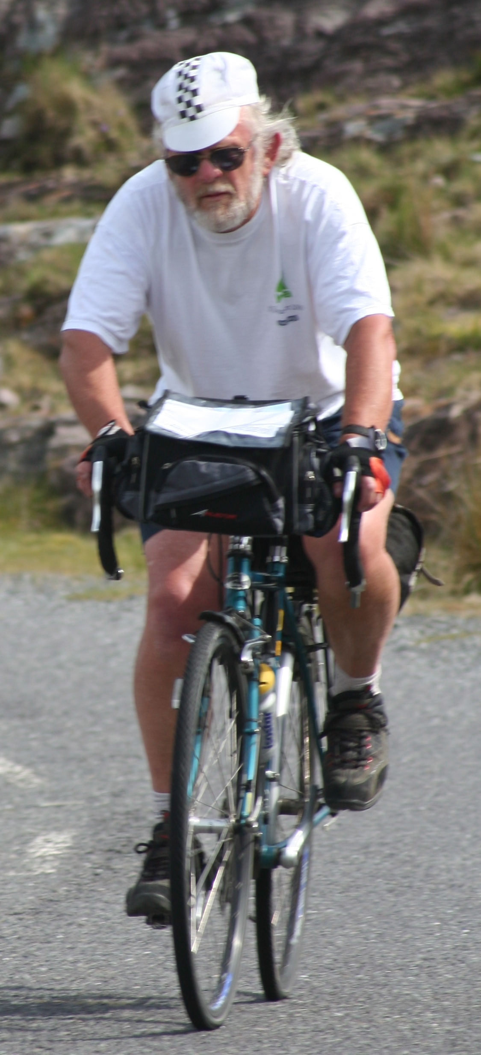  Amount £

